Lab 4-Sensors

## Learning Outcomes:

* Learn how to work a sensor
* Learn about the ultrasonic sensor

## Background:

Electrical engineers use all kinds of sensors for a variety of applications. It could be a LIDAR module on a self-driving car or a thermocouple in an indoor air conditioning system. Regardless, the purpose of sensors are to record some measurement from the outside world, and turn it into an electrical signal which is then analyzed by a device. [Different Types of Sensors and their Uses (i.e. Electrical Sensors)](https://www.thomasnet.com/articles/instruments-controls/sensors/#applications)

Sensors first use an electro-mechanical device to measure something in the real world. The sensor then converts the real-world measurement into a digital or analog signal. A digital signal is composed of bits. Each bit is either a low voltage (0) or high voltage (1). This is what computational devices like your computer use. In contrast, an analog signal can exist within a range of voltages, not just high or low. Regardless of the output type, the sensor communicates the data to a controller from processing. After processing, the controller can then act on the world.

With the advent of the internet of things ([Internet of things](https://en.wikipedia.org/wiki/Internet_of_things)), sensors are more important than ever. It’s crucial to understand how they work, and how to use them effectively. When using a sensor that you’re unfamiliar with, it is useful to refer to its datasheet—you can find all sorts of useful information there. For our AutonoMouse we will be using HC-SR04 which is an ultrasonic sensor. Read more about it here: [How HC-SR04 Ultrasonic Sensor Works & How to Interface It With Arduino](https://lastminuteengineers.com/arduino-sr04-ultrasonic-sensor-tutorial/)

The project objectives for today’s lab are to:

1) Correctly set up the HC-SR04 ultrasonic sensor

2) Read the data using Arduino’s serial monitor.

### Part 1 Ultrasonic Sensor Circuit:

Build the following circuit.

1. Put Arduino Nano into the center of the breadboard
2. Put wires connect the following pins (Arduino Nano on left, HC-SR04 on right)
   1. 5-volt pin (5V) and VCC
   2. Pin 12 (D12) and TRIG
   3. Pin 11 (D11) and ECHO
   4. Ground pin (GND) and GND

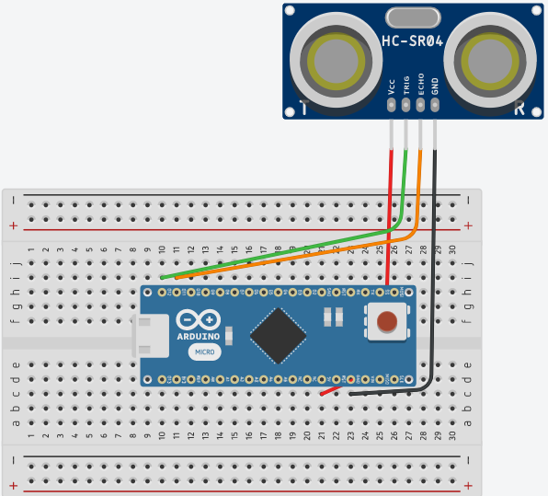

*Ultrasonic Sensor Circuit from Tinkercad*

### Part 2 Reading via Serial Monitor:

Copy and upload the code provided with this lab on GitHub to the Arduino. Once the code is successfully uploaded, open a serial monitor through Arduino IDE by clicking the serial monitor button in the top right corner. You should see another window open that provides data from the ultrasonic sensor. **Make sure that the baud rate is set to 9600 or else you will see nothing in the serial monitor.** The baud rate is the rate information is based through. Try moving the sensor around and get a feel for its range and accuracy. Make sure it works correctly or else your car will not be able to stop in the next lab.

